Chapter 4 Exercise 4.5

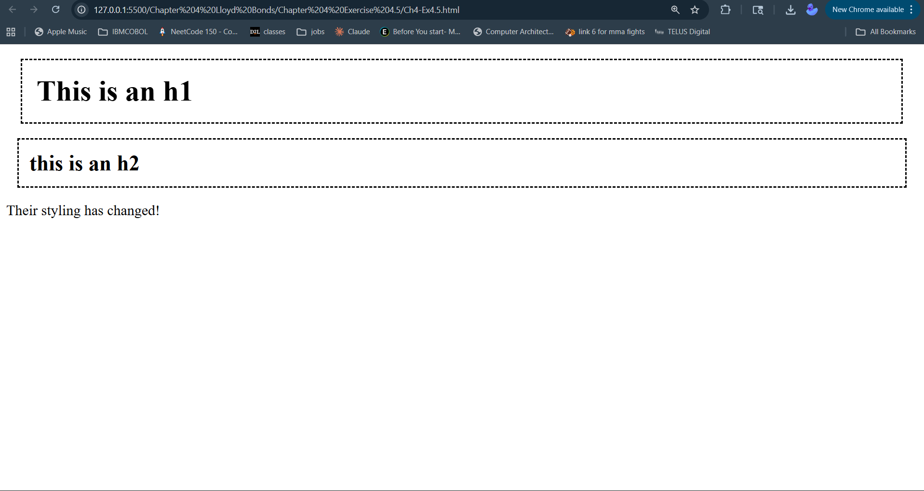

Chapter 4 Exercise 4.6
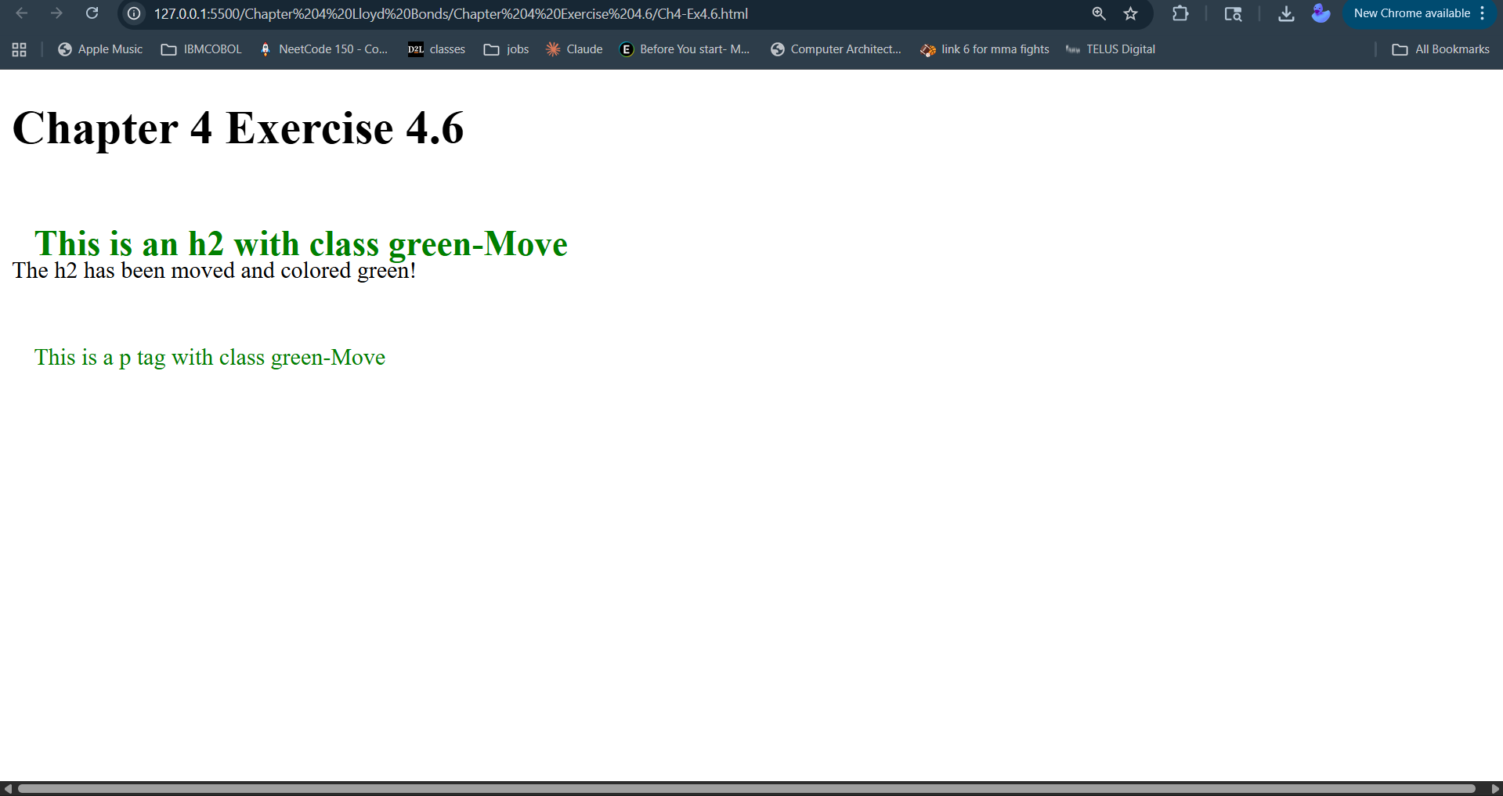

Chapter 5 Exercise 5.3
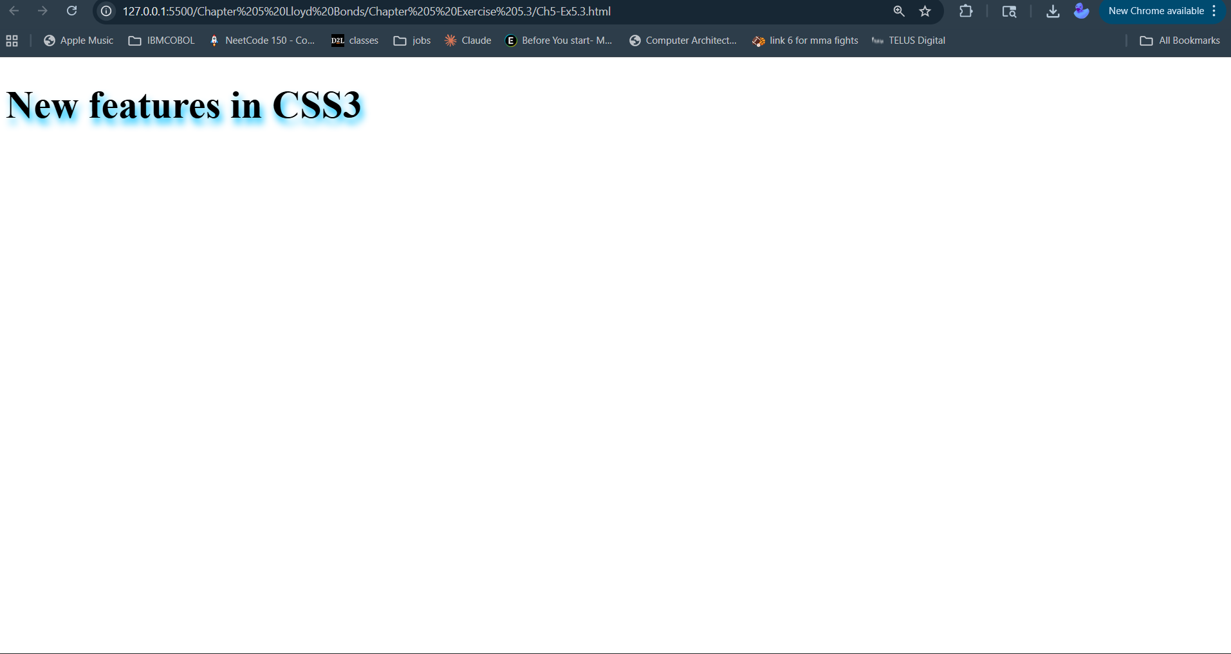

Chapter 5 Exercise 5.4

